University of Canberra

Faculty of Science and Technology

**Programming for Data Science G (11521)**

**Week 12 Tutorial**

**GUI, Cross Validation and Python Class**

**Objectives**

* To implement a simple graphical user interface (GUI) application
* To implement a cross validation program to find best parameters.
* To create a class and add fields and methods to this class.

**Project**

* Create a new project **Week12Tutorial** using Visual Studio or PyCharm

**GUI App**

* You will use examples in Python GUI lecture (Week 6) to implement this app
* Add a new file to project and name it **gui_app.py**.
* Add the following code to create a window with title, size and offset then run it

import tkinter as tk

window = tk.Tk()

window.title('Programming for Data Science')

# width x height + x_offset + y_offset:

window.geometry("500x250+100+100")

window.mainloop()

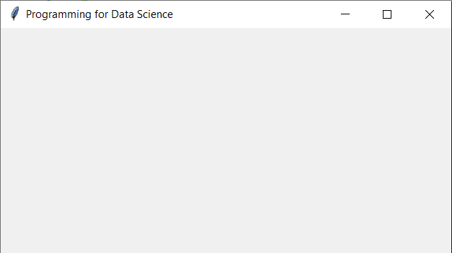

* **Note: all Python code in the next steps must be added to the place shown below**

window.geometry("500x250+100+100")

Add Python code in the next steps here

window.mainloop()

* Add the following code to set font and display a label on that window

#Set font

myfont = "Arial, 16"

#Add a label

lbl_header = tk.Label(text="A Simple GUI App", font=myfont, height=1)

lbl_header.place(x=150, y=10)

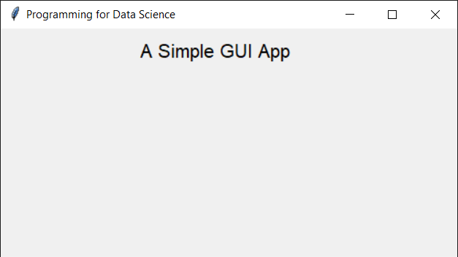

* And a label and two radio buttons for user to select a colour

#Add label

lbl = tk.Label(text="Select a colour: ", fg="navy", anchor="w", width=25, height=1, font=myfont)

lbl.place(x=10, y=50)

#Add variable var and 2 radio buttons

var = tk.StringVar()

rb1 = tk.Radiobutton(text="red", variable=var, value='r', font=myfont)

rb1.place(x=180, y=50)

rb1.deselect()

rb2 = tk.Radiobutton(text="blue", variable=var, value='b', font=myfont)

rb2.place(x=250, y=50)

rb2.deselect()

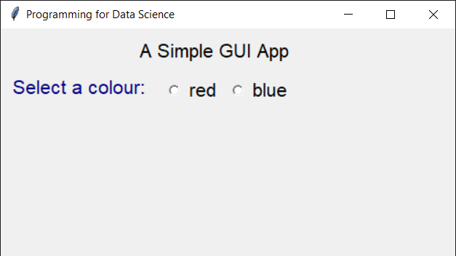

* The two radio buttons have the same variable var and have their own value ('r' or 'b'). When the user selects a radio button, its value will be set to the variable var.
* You will add a button for the user to click after the user selects a colour. You will also add another label to display a message that shows what colour the user has selected. This is done by the function select_item attached to the button. Add the following code to do that

#Label to display output when button is clicked

lb_output = tk.Label(text="", fg="navy", anchor="w", width=25, height=1, font=myfont)

lb_output.place(x=10, y=100)

#################################

def select_item():

selected = var.get()

if selected == 'r':

output = 'Red selected'

elif selected == 'b':

output = 'Blue selected'

else:

output = "Please select a colour"

lb_output.config(text=output)

#################################

#Add button

button = tk.Button(text="Run", fg="black", bg="lightblue", width=10, height=1, font=myfont, command=select_item)

button.place(x=10, y=150)

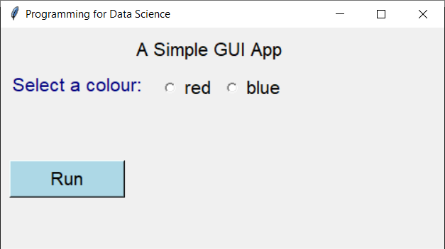

* Now you run the program. Click the button to see the message then select a radio button then click the button again.

**Parameter estimation using grid search with cross-validation for Classification**

* You will write a program to implement Step 6 in Assignment 2 here using **GridSearchCV** function in **Scikit-learn** package. This function will input a classifier with different values of its parameter, a training dataset, and a score. The function will then partition the training dataset into K subsets, where K-1 subsets are used to train the classifier with different parameter values and the remaining subset is to validate the classifier. The **GridSearchCV** function will output scores and parameter values and selects the best parameter value that corresponds to the highest score.
* Add a new Python file to your project and name it **gridsearchcv.py**.
* Add the following code to load dataset, parameter (n_neighbors), and classifier (KNeighborsClassifier) that you already tried them in last week’s tutorial)

from sklearn import datasets, neighbors, metrics, mixture, svm

from sklearn.model_selection import train_test_split, GridSearchCV

import matplotlib.pyplot as plt

import numpy as np

# Loading a dataset

dataset = datasets.load_iris()

X = dataset.data

y = dataset.target

class_names = dataset.target_names

# Split the dataset into training and testing sets

X_train, X_test, y_train, y_test = train_test_split(

X, y, test_size=0.3, random_state=0)

# Load classifier and its parameter for cross-validation

parameter = [{'n_neighbors': [1, 2, 3, 4, 5]}]

classifier = neighbors.KNeighborsClassifier()

* Add the following code to load grid search cross validation function for parameter estimation

# Load grid search cross validation

gscv_classifier = GridSearchCV(

estimator=classifier,

param_grid=parameter,

cv=5, #5-fold cross validation

scoring='accuracy'

)

* This function returns classifier gscv_classifier and we use it to train the training set

gscv_classifier.fit(X_train, y_train)

* Get parameter values, scores (accuracies) and best parameter from this gscv_classifier classifier

print("Grid scores on validation set:")

print()

means = gscv_classifier.cv_results_['mean_test_score']

stds = gscv_classifier.cv_results_['std_test_score']

results = gscv_classifier.cv_results_['params']

for mean, std, param in zip(means, stds, results):

print("Parameter: %r, accuracy: %0.3f (+/-%0.03f)" % (param, mean, std*2))

print()

print("Best parameter:", gscv_classifier.best_params_)

* This gscv_classifier classifier now applies the best parameter, so we just use it to test the testing dataset

y_pred = gscv_classifier.predict(X_test)

* Plot confusion matrix and accuracy

accuracy = metrics.accuracy_score(y_test, y_pred) * 100

plotcm = metrics.plot_confusion_matrix(gscv_classifier, X_test, y_test, display_labels=class_names)

plotcm.ax_.set_title('Accuracy = {0:.2f}%'.format(accuracy))

plt.show()

* Run the program.

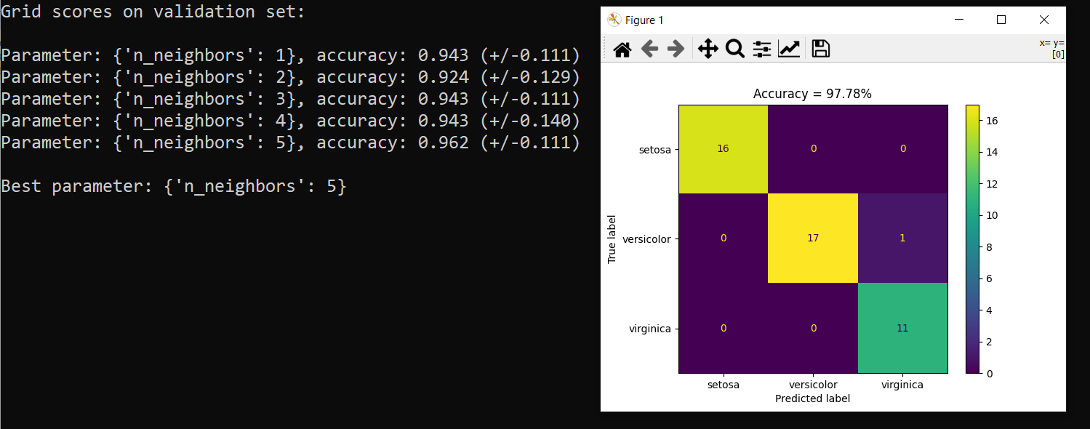

* Change test_size=0.3 to test_size=0.25, or test_size=0.2 and run your program to see the outputs.
* Change the current dataset (datasets.load_iris()) to **breast cancer** dataset (dataset = datasets.load_breast_cancer()) or wine (dataset = datasets.load_wine()) and run your program.

**Question 1:**

* Modify your program to run the SVM classifier (svm.SVC()) and its parameter gamma with the following values: 0.0001, 0.001, 0.01, 0.1, and 1.0..
* Output for the wine dataset, test_size=0.3

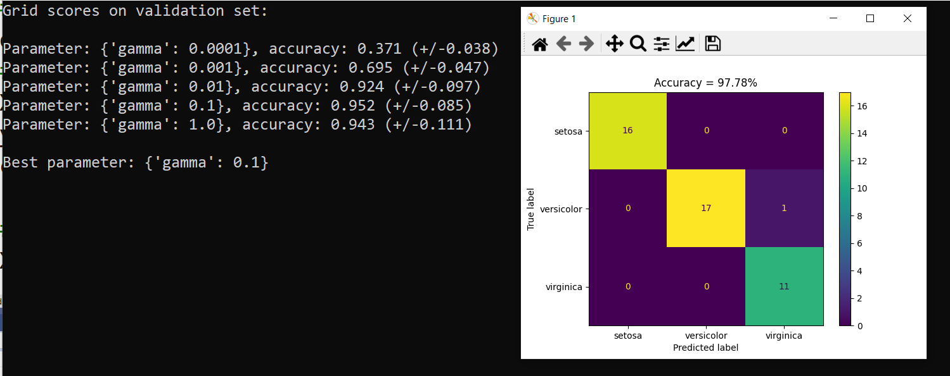

* Output for the iris dataset, test_size=0.3

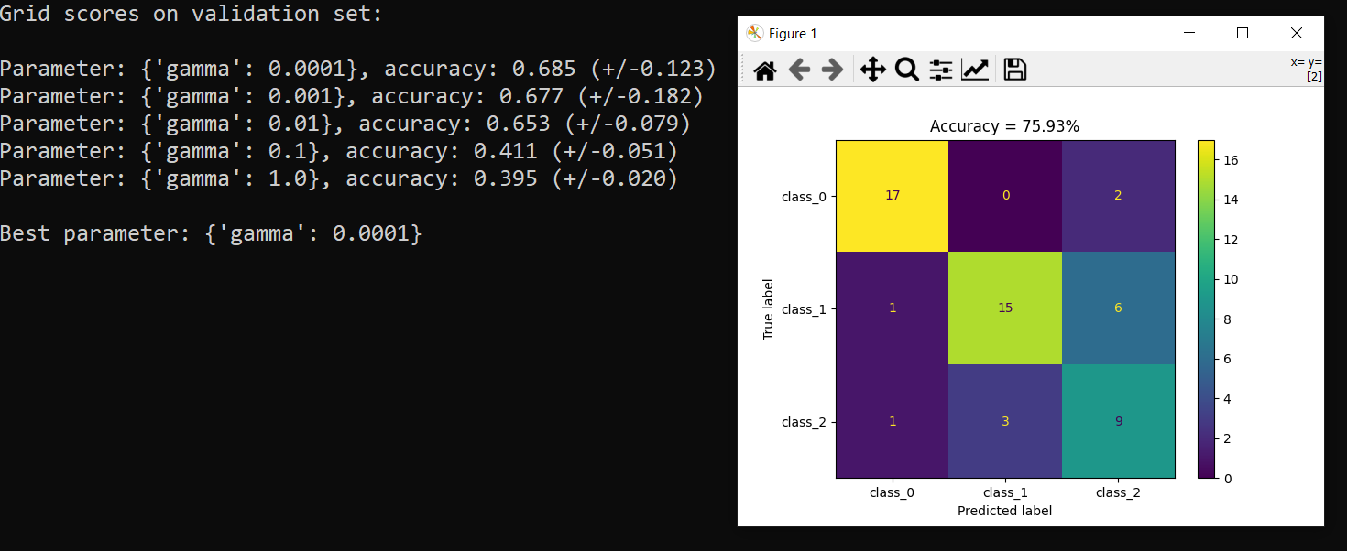

**Question 2 (Python Class):**

* Add a new file to the project to implement a Python class that is similar to the Phone class in lecture with the following details
  + Class name: **Computer**
  + Class variable: **brand**
  + Object variables: **model** and **harddisk**
  + __init__ method to set up initial values for all variables
  + Class method: **change_brand** to change brand
  + Object methods: **change_model** and **change_harddisk** to change model and harddisk, respectively.
* Write a program that creates 2 instances (objects) of Computer class and call all methods to change all the fields and to demonstrate the differences between class method and object method.

--END--